Department of Computer Science, CUI Lahore Campus
 | Assignment = Quiz 2
Name: | Section: | Course Title: Software Project Management | Date:
Reg.#: | Instructor: Sana Rizwan | Marks: 5 | Class/Batch:

Instructions
- DO NOT copy the assignment, marks will be graded on originality of work, zero mark will be for copied one. Assignment will be checked by Plagiarism software
- Each question has 01 mark
- Submission date is 19th April 2020 (Sunday)
- Submit the assignment using MS Word individually. Image file is not acceptable.
- Submit the assignment before closing date on Microsoft Teams.

Question 1:
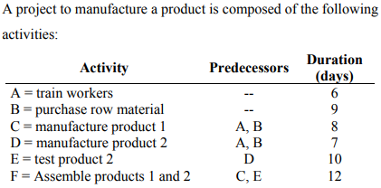
Draw the Network Diagram shown activities on arrows (AOA).

Question 2:
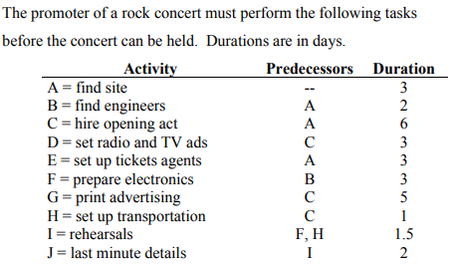
Draw the ADN Diagram shown activities on arrows (AOA).

Question 3:
Activity | Preceding Activity | Normal Time (Days)
1-2 | -- | 20
1-3 | -- | 25
2-3 | 1-2 | 10
2-4 | 1-2 | 12
3-4 | 1-3 , 2-3 | 5
4-5 | 2-4 , 3-4 | 10

Draw activity network diagram and identify the time allocation.

Question 4:
Activity | Optimistic Time | Mostly Likely Time | Pessimistic Time
A | 4 | 10 | 16
B | 3 | 6 | 9
C | 4 | 7 | 16
D | 5 | 5 | 5
E | 8 | 11 | 32
F | 4 | 10 | 16
G | 2 | 5 | 8

Calculate Expected Mean Duration, variance and Standard Deviation of each activity.
Question 5:
Activities | Predecessors | to | tm | tp
A | -- | 6 | 9 | 12
B | A | 14 | 17 | 20
C | A | 7 | 10 | 13
D | A | 3 | 5 | 9
E | -- | 4 | 7 | 8
F | E | 9 | 11 | 12
G | C,F | 10 | 14 | 16
H | F,G | 17 | 20 | 25
I | C | 12 | 15 | 18
J | B | 13 | 18 | 25

- Draw the ADN network diagram for Pert.
- Find the Expected mean duration and variance for each activity

THE END

